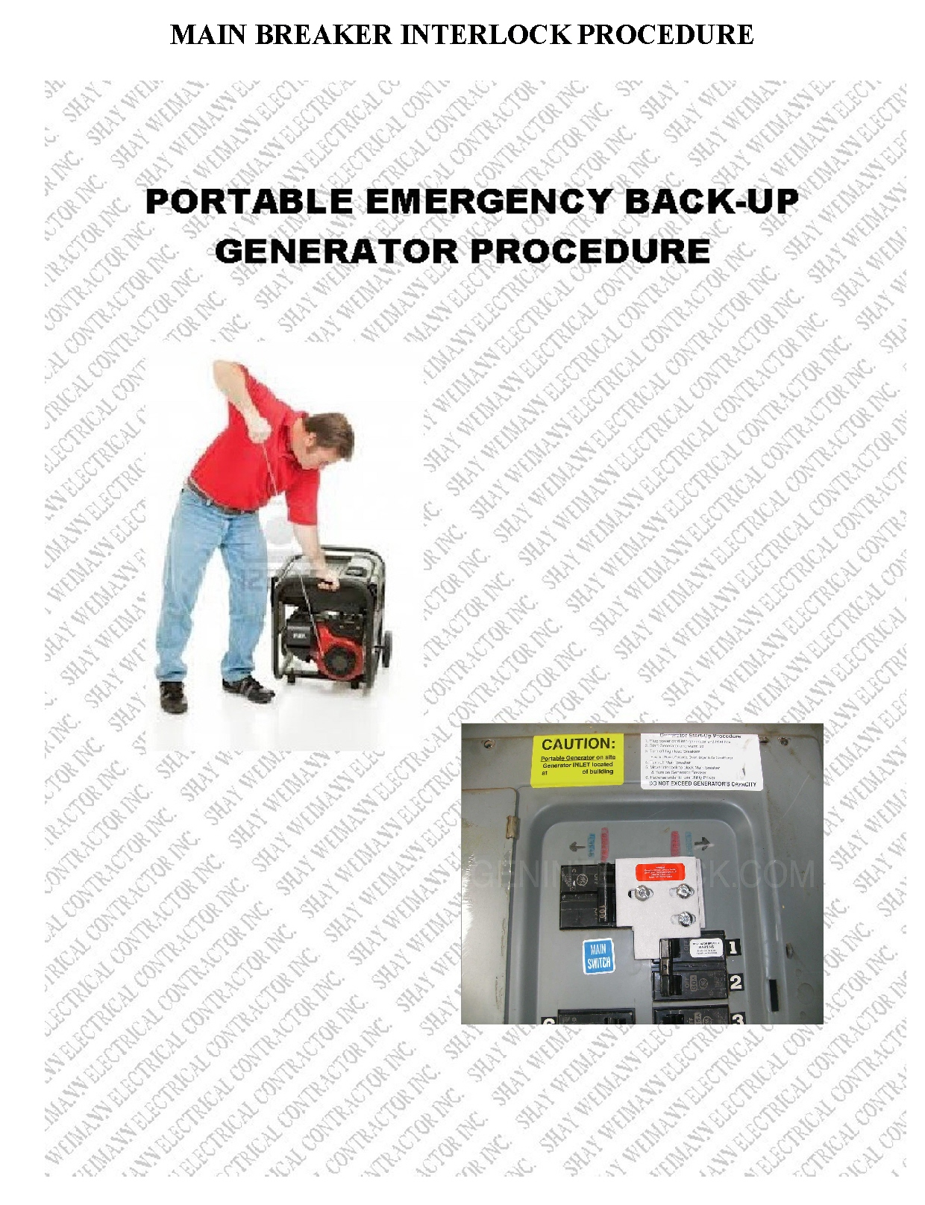

PORTABLE EMERGENCY BACK-UP GENERATOR PROCEDURE WITH MAIN BREAKER INTERLOCK

NOTE- Check with generator manufacturer/manual to see if a driven ground is needed for your particular generator make and model. Follow manufacturers instruction closely on break-in oil and oil change procedure for your generator.

A. Outage Procedure

- At loss of power turn off Main breaker in main panel. (This step is a mandatory measure and should be performed at any power company failure with or without use of generator due to sudden power spikes that can occur during power company’s reinstatement of power. It is suggested to wait 30 minutes after power company restores power before turning on main breaker to protect vulnerable electrical equipment in your home from power spikes or voltage drop. Check neighboring homes for lights on and normality before turning on main breaker.

- Turn off all circuit breakers in main panel. Your generator back-feed circuit should already be off and locked out.

- Set up generator – Connect driven ground if required (again, check with manufacturer for driven ground requirements). Do Not set up generator near open windows or enclosed spaces due to carbon monoxide poison. Insure proper ventilation. Do Not set up generator in standing water. Insure proper drainage to avoid electrocution. Check generator jumper cord for any damage. Generator cord should be stored in a safe place. Follow your generators manual for proper fueling of generator

- Plug in generator twist lock jumper cord and connect from generator to power inlet.

- Start Generator – As per generator manufacturer instructions. Take proper precautions against shock or electrocution in bad weather conditions.

- Switch interlock switch to lock out main and turn on generator back-feed breaker. Now main should be locked out and generator back feed breaker locked on.

- Slowly turn on circuits in main panel (following provided load shed schedule) one at a time to insure generator can catch up with oncoming loads (heavier loads will cause generator to bog down. Give ample time to let generator catch up)
Depending on the size of your generator you may not be able to energize all circuits at once. Use only circuits needed for emergency. Unopened freezers and refrigerators will keep food cold and or frozen for long periods of time without power. Be selective of balancing loads on generator.

- Once connected, loads in generator panel have been energized. Continue on backup power till needed. Be sure to follow manufacturers’ instructions of refueling generator, if needed. Generator should not be running during fueling with liquid fuel. Monitor local emergency weather stations for safety and evacuation instructions. Keep list of local radio and television stations near generator equipment or main panel.

- After power company reinstates power wait suggested 30 minutes wait time before switching back to power company system to avoid spikes from power company reenergization..

B. Restored power and generator power down procedure.

- Turn off circuits in main panel.

- If safety permits turn off generator and remove jumper cord. If safety does not permit, generator may continue running until out of fuel. Check with manufacturer on generators issues with running out of fuel. Generator and cord may be attended to at another time when climate permits.

- Insure generator back-feed breaker is turned off and locked out and reset main breaker.

- Slowly turn on circuits in main panel

All power should be back to normal. If not, a call to power company may be needed and power outage procedure may need to be repeated. Be sure to tell power company you are running a back-up generator system.

NOTE: The above procedures are only a suggested practice of operation during power outage and may not apply to all emergency situations.

Please keep advised of local authorities’ instructions during emergency situations and take all necessary precautions. Practice of this procedure/test runs should be performed prior to need of system in an emergency to avoid mistakes that can be made in a stressful emergency situation. Generator system and procedure should be test run bi-yearly to refresh procedures and insure generator is in working order.

Disclaimer –Please follow instructions for use provided by generator manufacturer. This procedure is for informational purposes only. Shay Weimann Electrical Contractor, Inc. shall not be responsible for your improper usage of your generator backup power system.

